**Software Engineering Challenge**

**Requirements**

**Describe the challenge or problem, what does the program need to do**

Create a city with light blinking animations and cars

Have it display neon lights at night

**What classes/objects do you think you need?**

window lights, buildings, cars, signs, neon lights, ground, road, sky, sun/moon

**How much time do you think you will you need to complete the project?**

\many hours

**Research**

**What knowledge or skills will you need to build this program**

How to animate the sprites/drawings

how to draw

**Do you foresee any problems or constraints, describe**

Displaying neon signs in night phase

**Have you created a similar programs? Are there similar programs in the book or other resources?**

No

**If so, what elements of that project can you bring to this project?**

**Do you have the resources you need to create the program?**

Yes, I can look at the Lineup/stick figure examples

**Do you need to learn any new knowledge or skill(s) to create the program?**

How to slowly shift the sky from one color to another

**Design**

Draw/create a basic graphic you plan to build - attach the drawing

If I can’t draw the words/symbols then I will just replace them with hollow rectangles

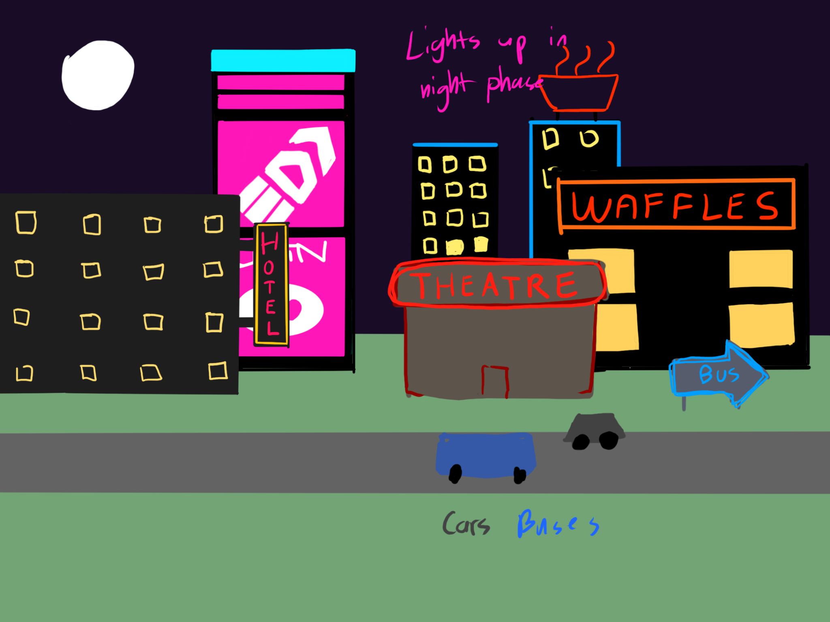

(paint, word, photo shop) not every objet (draw one example although there may be several in the final program) needs to be in the basic graphic

Include a task list--what will you need to do and in what order

Estimate the amount of time you will need to complete each part the project

**Construction – included in summary doc**

Document your construction progress with date and progress made (build a chart/table in word or excel), also, include at least three screen shots of your city (beginning, middle, and end)

**Testing/Results/Delivery—summary doc not required to start project**

Preliminary testing

Does your program meet the needs of the initial challenge or problem? How do you know?

Are any changes or modifications needed, why or why not? Document any changes.

Summarize the project - what worked, what didn’t work, note your successes and/or failures.

Looking back, would you have done anything differently, why or why not

Software Summary Document

Daily Progress Report

| Date | Description |
| --- | --- |
| January 12, 2023 | Draw road, ground |
| Jan 17, 2023  Make windows blink | they are blinking now |
| Jan 18  Make more buildings, signs, a car animation | I made a skrunkly tiny little car bruh    oops need to draw the cars after the road lines bt whatever i can fix that  i also need to fix the wheels  make hotel signs light up at nigh!! |
| Jan 19, 2023  Make signs light up at night |  |
| Ok I added a sun and moon (it slightly desyncs the longer it goes thougH) |  |

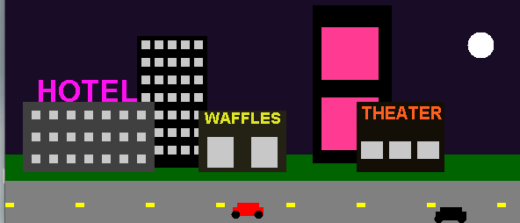

1 more car